June 6, 2020

Dear Neighbor,

First and foremost, we hope that you and your family have been able to stay safe and healthy during this time of pandemic.
Our family is hurting. In light of recent events, we are reaching out to you for support. We have lived in this neighborhood for 30 years, we raised 3 girls here, and we are very grateful to have always felt welcomed and supported in this community. We ask that you please read this letter with an open heart, and put aside any political affiliations or personal beliefs that you hold. We are writing to you as a fellow neighbor and human being.
If you are paying attention to the news, then you are aware that millions of people have taken to the streets across the U.S. and the world to protest the death of George Floyd, a black man who was tragically killed by Derek Chauvin, a former police officer in Minneapolis, Minnesota who knelt on Floyd’s neck after arresting him for suspicion of using a counterfeit $20 bill. George Floyd’s death was captured on video and went viral on social media platforms. If you haven’t done so already, we highly recommend that you watch this video to witness the sort of violence and abuse of power that happens far too often in our current policing system.
According to the Washington Post, 2,129 Black and Hispanic Americans have been killed by the police since January 1, 2015. In March of this year, Louisville police used a battering ram to crash into the apartment of Breonna Taylor, a 26-year-old black emergency room technician, and shot her eight times. The police were investigating a crime that she had nothing to do with, and to date no officer has faced legal consequences. In 2010, Aiyana Stanley-Jones, a 7-year-old black girl was fatally shot in the head while asleep in her own home during a raid conducted by Detroit Police. In 2014, Tamir Rice, a 12-year-old black boy was shot and killed by Cleveland Police while playing in the park. The list goes on and on.
We know that there are many good police officers who do not hold racist beliefs, who are a part of our community, and who strive every day to keep our communities safe. We know some of these officers personally, and we believe that most people who choose to become police officers do so out of a genuine desire to serve and protect. However, this issue is much bigger than “good cops” vs. “bad cops.” To truly address this problem, we must consider the underlying issues with the current system and structure of policing, which simply leaves too much room for well-intentioned officers to act on their own unconscious racial bias, resulting in the disproportionate targeting and killing of black people.
Our family is in pain right now. Over the past week, our minds have been consumed by intense stress, anxiety, fear, and sadness about the racism that continues to affect communities across America. It is impossible to think about anything else when we know that there are people in our country who stay silent and look the other way when these tragic events occur. We have been crying about this issue for our entire lives, and we desperately want a solution to this problem.
Race is often not a topic of discussion in our communities here in South Windsor, CT. We are one of four black families that live in this neighborhood, and our girls grew up going to school, working with, and playing with mostly white children. We chose to raise our family here for the same reasons that many of you did—this community offers physical safety, comfort, good education, and opportunities for our children. We have never experienced violent forms of racism while living here, and our girls have been able to thrive in school and other activities alongside their white friends. While we personally have never experienced racism from a police officer in this community, this is not the case for too many of our fellow Americans. If you ask other black families, especially those who live in large cities, they will tell you a very different story—one filled with too much fear, trauma, and profound sadness caused by policing systems.
We as a family affirm that black lives matter because we believe that EVERY life is inherently valuable. We ALL deserve to live in peace. No parent should ever fear that their child might not return home one night because they could be accidentally killed through an interaction with the police. And no child should ever have to lose a parent because a police officer accidentally killed them. To make this a reality in America we must come together to oppose the unjust killings of black people. While we might all have different opinions on how these changes should be made, we hope that, at the very least, you agree with us that black life is inherently valuable, and that black people do not deserve to be targeted and killed.
This is a cause that we cannot support alone. In fact, white people have historically played an essential role in creating real change during movements that seek justice and equality in America. We need your support to protect black lives by calling for a change in our policing system that will stop the pattern of unjust killings of black Americans. Together, we can create a new system that protects ALL of us.
Please do not stay silent right now. We are begging you to show support in any way that you can. To help with this, we have created a website that organizes information for our neighbors to learn more about this problem and do something to help. Please visit www.dearneighborblm.org and please share this information with everyone you know.
If you have any concerns, or if you are interested in finding ways to continue this important conversation here in our neighborhood, please feel free to email us at dearneighborblm@gmail.com. Thank you for taking the time to read this letter.

Sincerely,
The Lomba Family

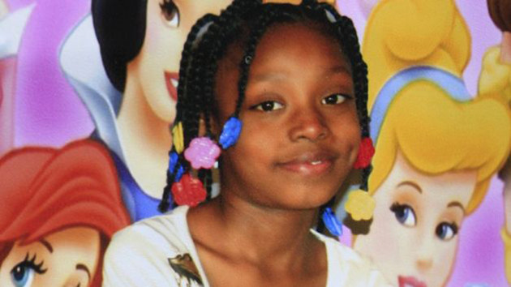
Aiyana Stanley-Jones, killed at age 7 by Detroit Police in 2010
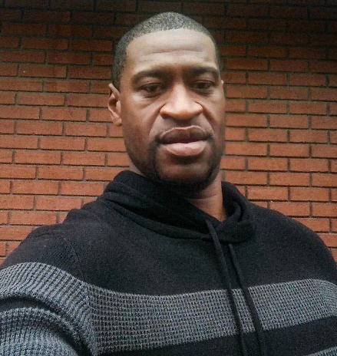
George Floyd, killed at age 46 by Minneapolis Police in 2020
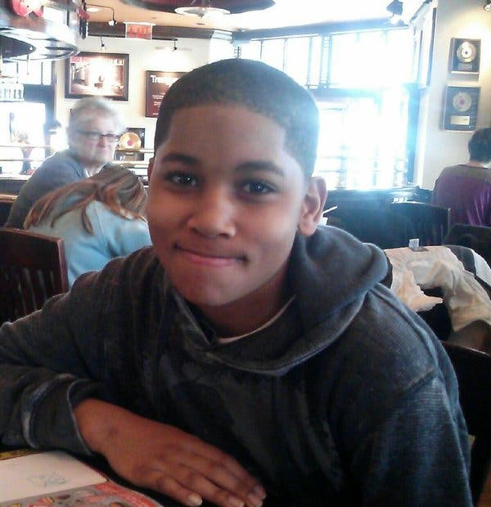
Tamir Rice, killed at age 12 by Cleveland Police in 2014
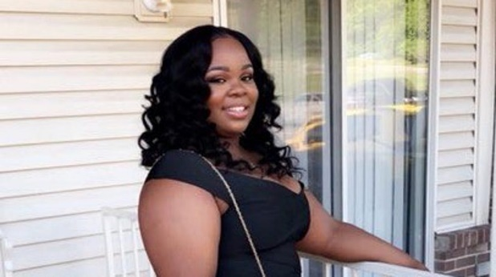
Breonna Taylor, killed at age 26 by Louisville Police in 2020
A Few Quotes:

“Black lives matter is not a political statement. It’s a human rights movement”

“A riot is the language of the unheard” – Dr. Martin Luther King Jr.

“If you are neutral in situations of injustice, you have chosen the side of the oppressor. If an elephant has its foot on the tail of a mouse and you say that you are neutral, the mouse will not appreciate your neutrality.” – Bishop Desmond Tutu.

“Many people are saying: it’s horrible that an innocent black person was killed, but destroying property has to stop.
Instead, let’s try saying: it’s horrible that property is being destroyed, but killing innocent black people has to stop.
Let’s be sure we’re prioritizing the right part.”

“We must take sides. Neutrality helps the oppressor, never the victim. Silence encourages the tormentor, never the tormented. Sometimes we must interfere. When human lives are endangered, when human dignity is in jeopardy, national borders and sensitivities become irrelevant. Wherever men and women are persecuted because of their race, religion, or political views, that place must - at that moment - become the center of the universe.”
― Elie Wiesel

“In the end, we will remember not the words of our enemies, but the silence of our friends”
— Dr. Martin Luther King Jr.

“White neighbors: we would rather you show up imperfectly than not show up at all”

